1.

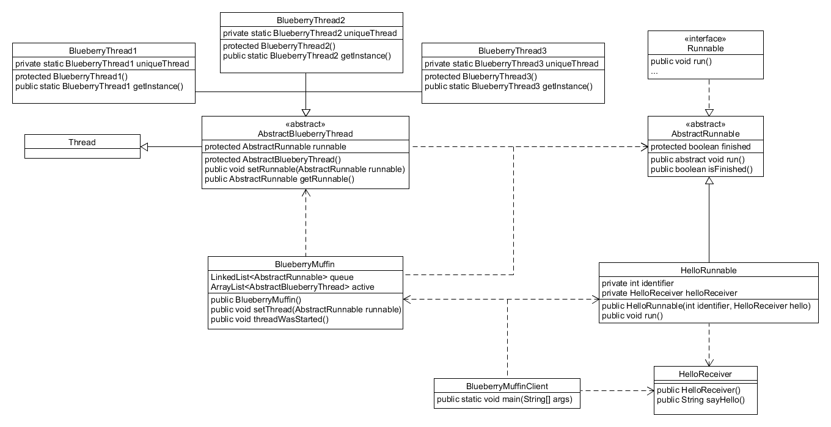

Factoring in the main thread, I created 3 threads that actually ran Runnables. These three threads are BlueberryThread1, BlueberryThread2, and BlueberryThread3. They extend an AbstractBlueberryThread which extends Thread. I made an initial AbstractBlueberryThread class to reduce code duplication and because of how I actually run the threads. I run the threads by assigning Runnables to them before calling run() on the Runnable. This way the threads are always the same but the execution of them is always different. The Runnables that I use are AbstractRunnables which implement the Runnable interface. Like the BlueberryThreads, I abstract the Runnable interface into a class to reduce code duplication and also to add some additional features. Each concrete Runnable takes a Receiver which directly affects how the Runnable will execute is run() method. The BlueberryMuffin class maintains all the extra threads in a LinkedList and maintains the three working threads in an ArrayList. The setThread() method assigns Runnable objects to each thread while the threadWasStarted() method actually calls the run() method for each thread’s Runnable object.